Table of Content

Contents
1. Purpose 2
2. Scope 2
3. Responsibilities 2
4. Procurement Procedure Annexure B (process flow): 3
5. Supplier Selection & Evaluation Criteria: 6
Annexure 1 17
Purchase Requisition Form 17
Annexure 2 18
Process Flow for Petty Cash Purchases 18
Annexure 3 19
Price Comparison Form 19
Annexure 4 20
Annexure 5 21
Procedure for Goods stacking 21
Annexure 6 23
Vendor Selection Form 23
Central Purchase Committee (CPC) 24
Purchase Order (PO) Disbursement Policy 26
Price Competitiveness Policy 27
Procedures for disposal of Assets & Goods 28
Procedure for Scrap Material and/or Waste Disposal 29
Store – Process Flow 31
PROJECT MANAGEMENT – BUILD OUTS 32
ROLES & RESPONSIBILITIES 33
Rental Negotiation Committee 34

1. Purpose
The purpose of this document is to provide a step-by-step guide and create an awareness for the procurement department to align all purchase activities with this defined procurement procedure to achieve the objectives of cost, quality, time accountability and transparency.

2. Scope
This procurement procedure is applicable to all purchases related to Zameen Media and associated companies that include both local & imported supplies.

3. Responsibilities
3.1. (Director / Senior Manager) Procurement is responsible to arrange resources of procurement, selection, pre-qualification and registration of new suppliers, he/she is responsible to monitor performance and evaluation of existing approved suppliers. (Director /Senior Manager) is responsible to make sure that all procurement activities are done in line with stipulated process.
3.2. Requesting departmental POCs are responsible to define specifications, quality, brand, frequency, of all required demands. After the delivery concerned departmental heads or their representatives are responsible to verify the specifications of supplies and signing of Material inspection form.
3.3. Manager Logistics is responsible to maintain the stock list with specifications, minimum stock level which is defined on the basis of past history (consumption) or on advice of concerned departmental POCs. Manager Logistics is also responsible for Record keeping related to receipt and issuance and liable to present it as and when required.
3.4. Procurement team will process all invoices and ensure availability of supporting documents before submitting to finance as per Annexure A

4. Procurement Procedure Annexure B (process flow):
Requisition: A system generated PR will be raised by concern department and in case of non-availability of system generated PR, it will be raised on a specified PR form (Ref annexure 1). It will be entertained upon submission to purchase (or store) department. It is the responsibility of the “Requisitioner” to generate requisition with all specifications, nomenclature, brand, model, make, description, quantity with required delivery date, otherwise it will be void. Procurement consists of the following two kinds.

- Monthly Purchase (Repeat Orders).
- Purchase on Demand.

4.1. Monthly Purchase (Repeat Order): Repeating items demands are processed on monthly basis. “Requisitions” are generated by procurement (IT equipment) and logistics team (only grocery & house-keeping) after compiling projected requirements for the whole next month with the objective to carry reserve stock to avoid stock out, to stabilize fluctuation in consumption, to have adequate materials on hand when needed, to minimize the inventory investment, to operate efficiently etc. Monthly requisitions will comprise the requirement of general supplies like Grocery, housekeeping, stationery and IT accessories.
4.2. Purchase on Demand:
For all on demand items purchase requisition will be generated by concerned department. With all documentary verifications and approvals.
4.3. Approval Procedure (Requisition):
4.3.1 Approval Procedure (Requisition)-For routine items:
For all routine on-demand items, approval of concerned departmental head will be required to process the PR. Requisitioner will arrange approval as per defined process
4.3.2 Approval Procedure (Requisition)-For non-routine items:
For all non-routine items which are having a specific nature and where PO cost is exceeding PKR 500,000 CPC approval is mandatory for the processing of PRs.

4.4 Petty/Low value Articles Purchase:
- Petty Cash Purchase (Up to PKR-15,000/-): Some items are purchased without adopting regular procurement procedures those are called as petty purchases. Procurement team member dealing with petty cash purchases will be responsible for all these purchases under the guidelines as per Annexure 2.
- 4.4.1 Procedure for Petty Cash Purchases:
Upon receipt of purchase request against petty cash, procurement team member will evaluate the request and will get 3 quotations from open market, quotations in a written form (any form of social media like WhatsApp, Skype etc.). After finalization of price, prescribed petty cash form will be filled with all required information and will be handed over to concern requisitioner/requester for approval from their HOD. Once it is approved/signed by concern HOD form will be approved by Director procurement to proceed the request. Once transaction is done all original documents will be handed over to finance team and a copy will be retained by procurement team.
4.5 purchases against purchase order:
For all items purchased against PO below procedure will be followed
4.5.1. Request for Quotation (RFQ): Upon receipt of purchase requisition procurement team will float RFQ to already approved vendors or float Tender document via print media, at least 3 comparative quotations will be finalized for further negotiation process.
One vendor will be shortlisted by adopting following procedure.
- A price negotiating call or meeting will be conducted by procurement department with the vendors.
- Negotiation will be based on; financial evaluation/competitive price, payment terms, product/ service quality, on time delivery, after sales services, warranties etc.
- Preparation of Comparative Statement, Negotiation Minutes, approval documents and conclusion is to be documented.
- Where CPC approval is mandatory. Approval from CPC committee will be considered as “final approval”.
Price comparison and negotiation is done and recorded via Annexure 3
4.6. Issuance of Purchase Order / Contract etc. Procurement department will solely be authorized to issue purchase order, contract, agreement or any other related documents mentioning all necessary details related to payment term, delivery location, etc with the signature of Manager Procurement or other authorized signatory to the vendor for supplies etc.
Work order is to be issued by the Admin department on the basis of rates negotiated by Procurement

4.7. Receipt and Verification of All of Materials: At the arrival of supplies, admin floor manager/security in charge will check the supplier documents, materials and issue the inward gate serial number and refer the vendor to store office or concerned persons. Receiver of the supplies is responsible to verify:
- Quantity / weight of the items received
- Specifications of material against PR
- Physical condition of the purchased items i.e. packaging whether its intact / damaged / leaked
- Compliance of handling instructions mentioned on the goods
- Expiry dates mentioned on the goods (where applicable)
- Goods serial # matching with packing/details provided (on all applicable items).
- Goods warranty details verification on applicable items (For IT equipment and Handsets IT department will conduct verification).
- In case of bulk items receipts, packing method will be verified and each box is to be checked for satisfactory confirmation of quantity as per delivery documents.
- Technical inspection will be carried out by designated technical team as per defined form
- Marketing collaterals & other items where concerned department inspection would be necessary will be carried out accordingly
In case of any discrepancies or nonconformance observed/found while inspection in presence of issuer, receiver will raise his/her concern with WHs senior management to obtain required assistance.
In such items where an inspection form is mandatory store in charge will inform all concerned persons for the physical inspection of received material as per Annexure 4 (inspection form). Once inspection is done inspection form will be filled and signed by all concerns.
Once all related formalities are fulfilled Store In-charge prepares Goods Receipt Note/General Stock Receipt through ERP System & update stock in the System.
Internal auditor audits the store on monthly basis, to monitor stock and inventory status.
Most of the goods received will require to be stored in Warehouse / on site store. The stacking of the goods will be done as per Annexure 5 (procedure for goods stacking)

All payment will be verified by Sr Manger Procurement and duly signed by Director Procurement for processing. For payment process following steps will be taken by concern procurement resource.

- After delivery of the products, the invoice should be cross checked against the PO of that particular order.
- A copy of PO will be attached with relevant documents (as per Annexure A), then forwarded to the finance Department.
- A copy of above set of documents will be kept in the record of the procurement department.

4.8. Taxes
In accordance with the requirements of the Income Tax Ordinance currently applicable in Pakistan.

5. Supplier Selection & Evaluation Criteria:
5.1. Pre-Qualification and Approval of Supplier
Zameen Media encourages different vendors to get registered and doing business with us. Zameen Media works only with those vendors who are falling in our list of approved vendors / suppliers. For the purpose of vendor qualification, a detailed criteria is adopted.
For the purpose of vendor qualification information about different vendors is received through internet, personal relation, media post, email etc.
Following is the detail of Prequalification process,
- Vendors are invited to submit the company profiles for prequalification.
- Profiles are reviewed and vendor evaluation is performed on following basis:
- Market reputation, experience and reference of other clients
- Credit facilities
- Price
5.2. Vendor Selection Criteria Annexure 6:
The first section includes the basic information about the Procurement Personnel selecting and evaluating the Vendor. The information is as follow;

a) ‘Prepared By’ includes the name of the procurement personnel filling out the Vendor Evaluation Form.
b) ‘Title’ includes the designation of the procurement personnel responsible for evaluation
c) ‘Date’ includes the date on which the evaluation is being carried out.
d) ‘Vendor Referred By’ includes the name of the personnel by whom the vendor is being referred by.

Vendor Information:
Vendor Information, includes;
a) Company Name
b) Company Address
c) City
d) Contact Number
e) ‘Type of Business’- Whether it is Retail, Manufacturing, or Services.
f) Contact Number and Designation of Vendor’s representative.

g) ‘Vendor Type’- Whether it is for recurring products, new products, or services.

Vendor Selection Criteria (Minimum Qualifying Score 30/60)
5.2.1. Tax Status
Tax status of a Vendor has a major impact and is therefore taken under-consideration while shortlisting vendors.
1) If a vendor is a ‘Tax Filer’ then five points will be awarded.
2) ‘Sales Tax’- If a vendor has a Sales Tax number, three points will be awarded.
3) ‘SRO’s/Exemptions’ (applicable for import vendors only) - If a Vendor is eligible for exemptions for certain products, an exemption certificate needs to be provided and will be awarded two points for this eligibility.

5.3. Supplier’s History and Past Record
An organization’s overall history and past record makes the vendor selection process smooth and efficient. While taking ‘company’s history and past record’ under-consideration, three of the following factors are evaluated;
  - ‘Total Number of Years in Business’- Vendors are scored based on the total duration of their existence in the industry. The scoring criteria is as follow;
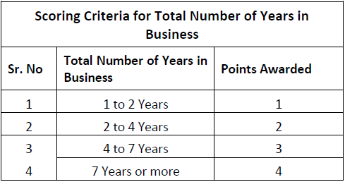

  - ‘Key Clients and Market Repute’- A supplier’s major clients reflect the ability and capability of a supplier to meet the overall demand. The overall presence and organizational structure will help in determining the significance of Vendor’s clientage. For each verified, satisfied client, a Vendor will be awarded one point. Having a strong overall market repute. A vendor’s overall market repute can be evaluated through;
a. Key Clients Reference Check: Conducting reference check of each key client will make it easier to evaluate vendor’s overall market repute. Against each reference check for a key client, the vendor will be awarded either ‘zero’ or ‘one’ point. The scoring system is as follow;
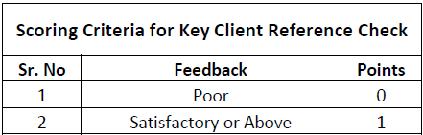

5.4. Payment Mode
Since, it’s the company’s policy to discourage ‘Cash buying’ and encourage ‘Purchase on Credit’, a vendor will be awarded a higher score if ‘credit payment terms’ are offered as opposed to a ‘score of zero’ if cash is the only mode of payment offered by the vendor.
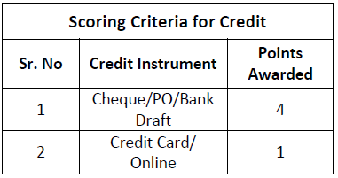

Furthermore, the flexibility of the credit line offered by the Vendor determines the number of points a vendor should be awarded. The scoring criteria is as follow;
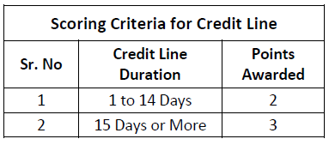
5.5. Company’s Registration Status
Score is awarded to Vendor based on its Company’s Registration Status. The scoring is as follow;

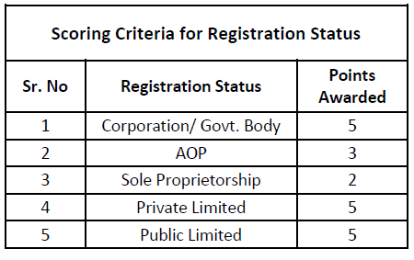
5.6. Company Setup Details and Analysis
Three important factors are taken under-consideration while evaluating a Vendor’s Business Setup. These factors include;
A) Vendor Footprint- The more spread out a Vendor’s business is in terms of geographical locations, more points will be awarded. Vendor’s Footprint is classified in to;

- Number of Offices: Vendor will be evaluated on the following criteria.

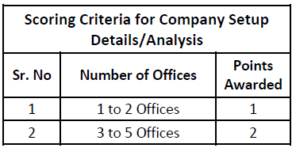

- Nationwide Existence: Vendor’s nationwide existence will be evaluated from its presence in metro cities and will be scored according to the criteria as shown below;

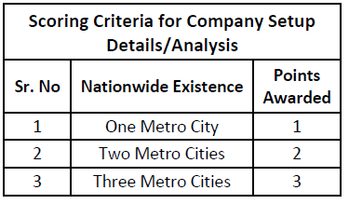

  - Workforce Strength- A vendor’s overall workforce strength depicts its ability to meet demand constantly and providing overall strength to an organization. Higher workforce will result in higher points. The score distribution is as follow;
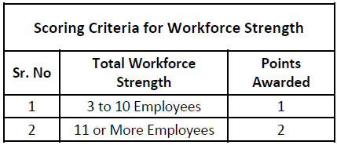

c) Capability to fulfill demand: A vendor’s capability to meet the customer requirements will be evaluated by its capacity to fulfill the order and its transportation system. The scoring criteria to evaluate a vendor’s capability to fulfill demand is as follow;
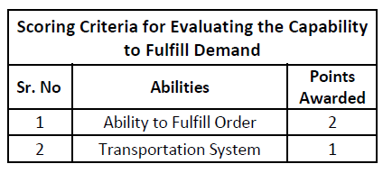
5.7. Terms and Conditions:
1) Market Competitive Pricing: During the ‘Vendor Selection Process’, it is of utmost importance to make sure that the prices, quoted by the vendor, are market competitive. This will be done through a thorough market research. If the prices quoted by the vendor are market competitive, lower than or equal to, the vendor will be awarded ‘four’ points, otherwise the vendor will be awarded with ‘Zero’ points.

2) Availability of Support Staff: The availability of support staff measures the competency of the overall level or services provided by the vendor. This includes; availability of the technical support staff, overall response time, and the cooperation of the support staff. If the vendor has an adequate number of after sales support staff then the vendor will be awarded ‘two’ points.

3) ‘Refunds for’ OR ‘Replacement of’ Rejected Items: Vendors who provide refunds for or replacement of rejected items will always be more preferable by the customer as opposed to the vendors who don’t. For instance, if a product delivered has been deemed ‘rejected’ due to quality constraints, a vendor who offers refunds (In case of non-replacement) or replacement for the specific product will be awarded ‘four’ points as opposed to the vendor who does not entertain refunds or replacement of the items delivered.

5.8. Internal Reference
If a vendor has been referred by an employee of the organization, points will be awarded to the vendor ‘out of five’. ‘Name, Designation, and Department’ of the employee will be recorded by whom the vendor has been referred. Vendor referred by an employee will be awarded points according to the designation of the employee. The relative scoring is as follow;

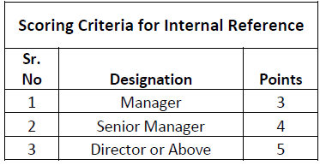

5.9. Vendor Evaluation Process:
After being selected, Vendor’s performance will be evaluated after every three months. Vendors will be evaluated and awarded points accordingly based on the following criteria

Scoring Criteria for Evaluating Vendor's Performance
Rating | Points Awarded | Description
Unsatisfactory | 0 | Vendor fails to deliver on quality, price & time
Development Needed | 1 | Vendor has potential to deliver but needs guidance
Satisfactory | 3 | Vendor is consistent on quality, price and time
Exceptional | 5 | Vendor is consistent in services / products at a min profit with the realization of becoming a business partner rather than a supplier

Each criterion, part of the Vendor Evaluation Criteria, has been assigned a weighted average. The overall score of the Vendor Evaluation is calculated based on the weighted average. The overall qualifying score is 50/100. The weighted average of each criterion is as follow;

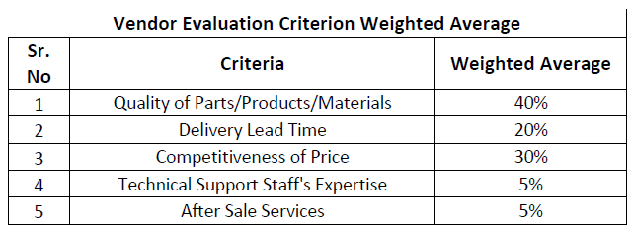

Sr.  No | PARAMETER | CRITERIA | WEIGHTED  AVERAGE
1 | Quality of Product/Service | 0-1 Complaint---------40  2-3 Complaints--------30  4-5 Complaints--------20  6-7 Complaints--------10  7-10 Complaints-------0 | 40%
2 | Delivery Lead Time | 100% on time---------20  80% on time----------15  60% on Time----------10  40% on Time-----------8  20 % on Time-----------4  0% on Time-------------0 | 20%
3 | Price Competitiveness | Cost Analysis | 20%
4 | Order Fulfillment | 5% cancel Po----------8  10% cancel Po---------4  Above 10%-------------0 | 10%
5 | After Sales Service | Repair/Technical support/Return | 5%
6 | Credit Offered | 30-45 Days------5  20-30 Days-------4  10-20 Days-------3  5-10 Days---------2  COD-----------------1  Advance-----------0 | 5%

Vendor’s performance will be evaluated by taking the following criteria under-consideration;

5.10. Delivery Lead Time: It is the vendor’s ability to fulfill the order within the desired time. As the ‘required delivery date’ is mentioned on the PO generated against a specific order, the ‘required delivery date’ should be cross-checked against the date on which the product was actually delivered. The vendor will then be evaluated on the criteria below;

Delivery Lead Time Scoring Criteria
Sr # | Scenario | Points Awarded
1 | All deliveries were before time | 5
2 | All deliveries were on time | 4
3 | 80 % deliveries were on time | 3
4 | 50 % deliveries were on time | 2
5 | 30 % deliveries were on time | 1
6 | less than 30 % deliveries were on time | 0

5.11. Competitiveness of Price: Vendor will be evaluated based on the prices being offered in comparison with the prices being offered by other vendors. ‘Price Comparison’ should be conducted after every two months by taking 3 quotes to make sure the prices being charged by the Vendor are market competitive. Vendor will be evaluated on the competitiveness of price based on the following criteria;

Competitiveness of Price Scoring Criteria
Sr # | Scenario | Points Awarded
1 | 10 % below Average Market Price | 5
2 | 5 % below Average Market Price | 4
3 | Same as Average Market Price | 3
4 | 5 % above Average Market Price | 2
5 | 10% above Average Market Price | 1
6 | Greater than 10 % Average market price | 0

5.12. Quality of Parts/Products/Materials and Services: After the delivery of a product and/or rendering of services, an inspection is carried out against which an inspection form in filled out to determine if the products supplied or services rendered meet the quality standards. Each inspection form will be able to determine supplier’s overall performance.
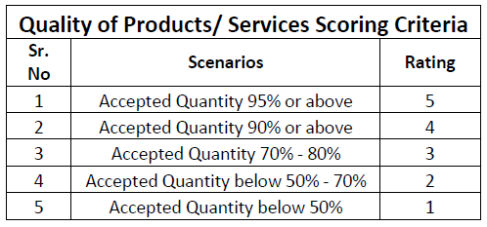

5.13. Technical Support Staff Expertise: Some products require technical expertise in order to be setup properly before use. A vendor’s overall ability to provide adequate technical support staff will be evaluated as;
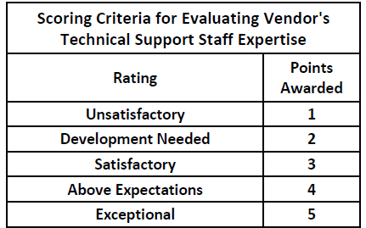

5.14. After Sales Services: It comprises of warranty claims, complaint handling / response, refunds and how well a vendor has been able to accommodate the customer in these areas. The vendor should be able to respond to all customer queries within the desired time to make it a hassle-free process. A vendor will be evaluated on how quickly and effectively the vendor has been able to resolve customer’s queries.
Furthermore, in some instances some vendors are blacklisted. Blacklisting of Vendor could be a result of the following;

a) Submission of Forged Documents
b) Consistent compromise on the Quality of Services/Products
c) Variance in price on invoice and quantity
d) Consistent partial or late deliveries
e) Other Reasons

6. Related Documents:
Relevant Forms and Process flows: All relevant forms and process flows are attached below. Further to below attachments there is a document ZAM/PUR/PF-01, which contains all process flows.

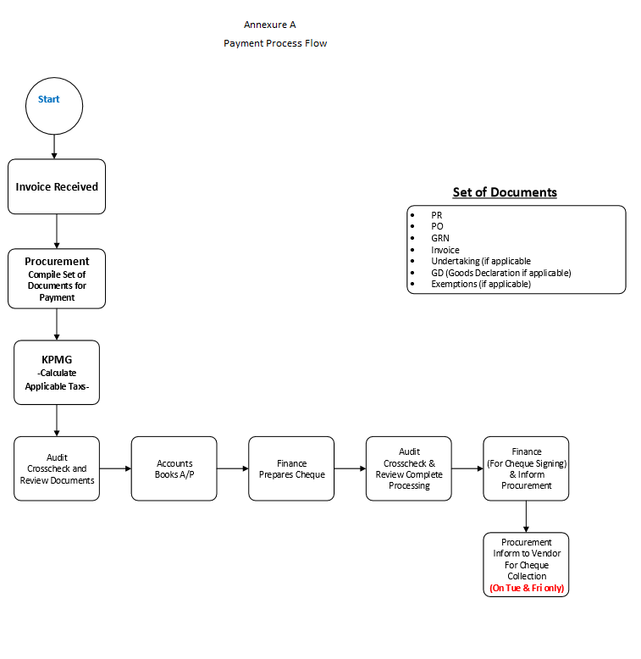

Annexure 1

Purchase Requisition Form

 |  |  |  |  | Purchase Requisition |  |  |  |  | Document Date:
Pearl One |  |  |  |  |  |  |  |  |  | Required Date:
94-B/1, MM Alam Road, |  |  |  |  |  |  |  |  |  | Document No:
Gulberg III, Lahore 54000
Punjab, Pakistan
Department |  | Description / Comments |  |  | Req Location |  | Required By |  | Approved By |  |  | Approval Status
 |  |  |  |  |  |  | Additional
Sr. No | Item Code |  | Description |  |  |  | Comments |  | Qty | UOM |  | Unit Cost | Total Cost | In Stock
1 |  |  |  |  |  |  |  |  |  |  |  |  | -
2 |  |  |  |  |  |  |  |  |  |  |  |  | -
3 |  |  |  |  |  |  |  |  |  |  |  |  | -
4 |  |  |  |  |  |  |  |  |  |  |  |  | -
 |  |  |  |  |  |  |  |  |  |  |  |  | - | -
Document Comments :
HOD / Regional Head
Sign : |  |  |  | Date:
Stamp: |  |  |  | Time:
*As per the Instructions of Management for approvals, 'Stamps', 'Date', 'Time' are compulsory to ensure compliance.

Annexure 2

Process Flow for Petty Cash Purchases

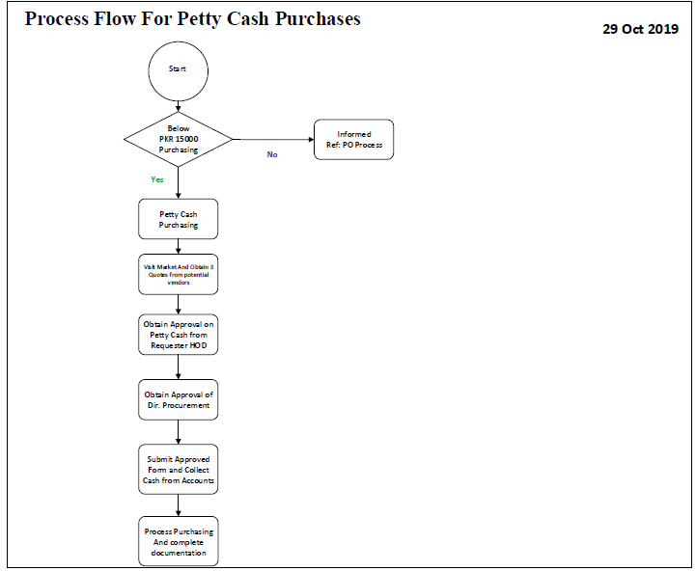

Annexure 3

Price Comparison Form
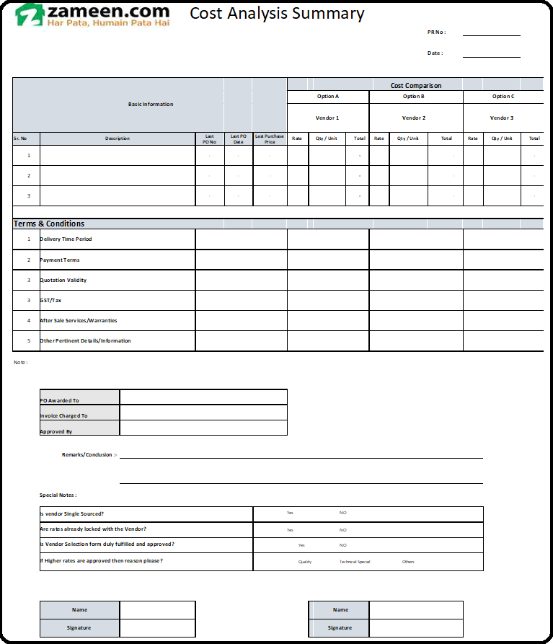

Annexure 4 Goods Inspection Form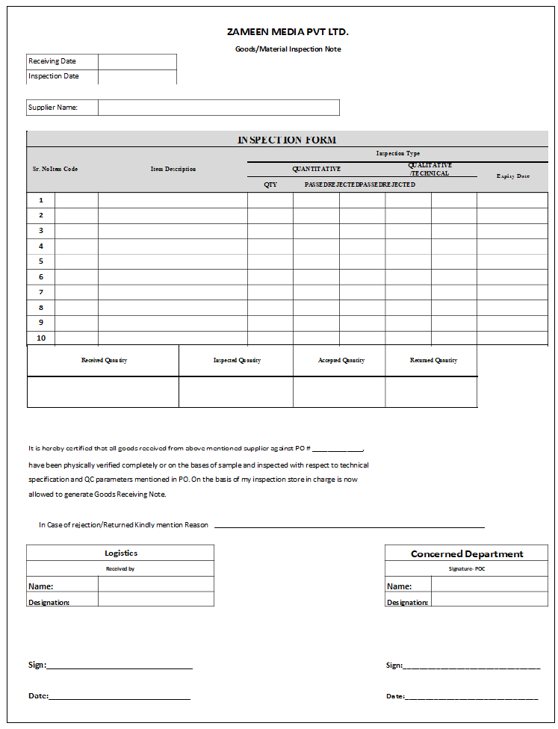

Annexure 5

Procedure for Goods stacking
The following procedure is to be followed to stack goods while in storage as well as when they are in transit.
Goods Stackable Area: Handling must adhere to the type of goods that is being handled. Its material, dimensions, handling instructions, weight and category must be kept in mind. Stacking needs to be done keeping a few factors in mind to ensure efficient execution of inbound and outbound activities. The warehouse design layout would make the job easier for smoother proceedings.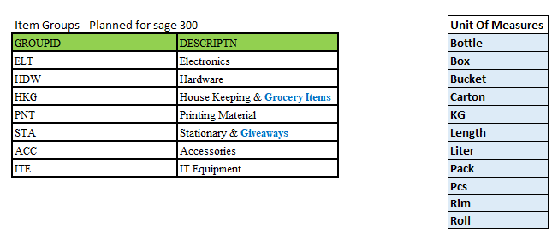

Goods Stacking Guidelines
- Areas will be specified for these items in all warehouses considering inbound & outbound frequencies.
- Warehouse layout design and category-wise indicators/tags will serve as guidance for appropriate stacking.
- Goods will only be stacked in designated stackable areas.
- Goods will be stacked to maintain FIFO method to ensure dissemination and depletion of items in chronological order (i.e. in sequence of arrival date and time).
- Goods will not be stacked near wires and electrical appliances.
- Goods will not be stacked near doors/walkways.
- Goods stored at height will be handled with portable stairways to ensure safe handling.

- Goods of heavier weightages will always be kept on ground storage/or on ground-level shelves of racks.
- In case of high volume and to cater for severe contingencies, the aisle area may be utilized. Slow moving goods will be placed here, and based on historic data, decisions will be made in consultation with the warehouse management team.
- Liquid items will be stacked on wooden pallets in their respective category of goods with handling instructions as mentioned on the goods.
- Handsets, laptops, and all high-value goods will be stacked in strong cabinets/strong rooms for strict monitoring with the appropriate entry and exit management.

- Handling of goods will be done with hand-jack pallets in case of heavy loads stacked on a wooden pallet.

- While stacking of goods on heights, careful judgment would be required to avoid tilting and collapsing of goods.

- In order to manage efficient use of space and appropriate stacking, in-house support or that of packing services will be acquired as and when required.
- Empty boxes should to be stacked in a separate area away from areas with inventory along with other related tools, such as cutters and packing tapes.
- While stacking, proper distance will be maintained to avoid mixing and stumbling of goods.
- Only authorized persons will be allowed to enter inventory stacking areas. Unauthorized entry/movement in inventory stacking area will be considered a severe violation and action will be taken according to the stipulated policies.
In case new goods arrive at the warehouses, stacking instructions will be communicated to all warehouses for strict compliance.

Annexure 6

Vendor Selection Form

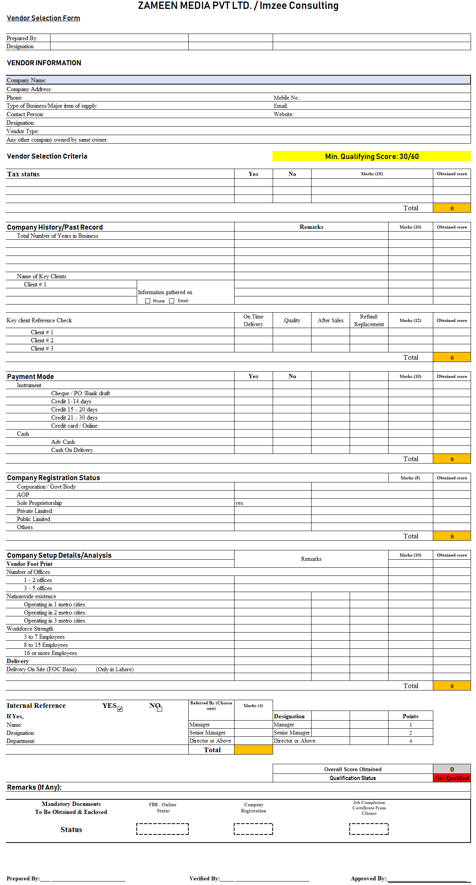

Central Purchase Committee (CPC)

Engagement Limit:
Procurement of Goods
- Greater than or Equal to PKR 500,000.
- If the value is below PKR 500,000 Procurement Department will take the decision independently as per the defined authority matrix.
Mandate:
- Any transaction including but not limited to:
  - SLA
  - Service Contracts
  - AMC (Annual Maintenance contract)
  - Buildouts
  - Onetime Purchases
  - Exceptional Purchases (Must be approved by CEO)

Composition Committee Members:
Member | Designation | Type
Mariam Saleem | Director Procurement | Permanent Member
Shahid Hassan | Director IT | Permanent Member
Faisal Nisar | Head of Supply Chain | Permanent Member
Tanzain Shafqat | Head of Finance | Permanent Member
Haseeb Malik | Head of Marketing | Permanent Member
Basil | Audit Dept. | Observer
Ibrahim | Director Marketing | Permanent Member
Adil Kamal | Head of Acquisition | Permanent Member
Head of Requisitioner Dept. | Concerned department | -

Meeting Frequency:
- Every Wednesday followed by management committee meeting.
- CPC shall convene as and when the need arises. HOD procurement or Admin shall be responsible to arrange meeting of the CPC.

Quorum Compliance:
- At least 3 permanent committee members must be present in addition to the Head of the requisitioner department.
Alternatively, all cases are to be presented by head/ nominated proxy of requisitioner department, failing which, case shall be deferred to next CPC.

Terms of Reference of CPC Committee:
The terms of reference of CPC Committee shall be as follows:
- Develop an overall governance structure for the procurement function and recommending; standard operating procedures and key performance indicators to ensure fair, competitive and transparent procurement;
- Evaluate and review the need assessment of the desired procurement.
- Selection of the vendors based on the quote analysis / comparative statement, environmental impact and technical evaluation including assessment of similar deployments, product experience and market reputation;
- Approval of Contract / Purchase Order with the selected supplier for purchases value exceeding PKR 500,000 based on technical, financial and legal implications of proposed contracts.
- All purchases above PKR 1,500,000 are to be approved by Office of CEO.
- A mechanism to evaluate suppliers as per management objectives and review of the supplier evaluation results to ensure that only fully qualified suppliers of specific fields are retained by Zameen Media Pvt. Ltd.
- Ensure minimization of procurement costs by directing the procurement function to negotiate bulk discounts with suppliers while ensuring quality.
- Take any decision with respect to procurement of goods and services as directed or delegated by the Office of CEO.
Services Acquisition or maintenance for Admin:
- Any acquisition of services not falling under the domain of Central Purchase Committee (CPC) will be fall under the domain of admin. However, before raising any work order it needs to be reviewed and approved by Internal Audit Department before the finalization of the order.

Decision Mechanism:
Once the quorum finalizes any decision, it is the responsibility of HOD Procurement or use dept (admin, HR etc) to share detailed email against the decision made to the committee members keeping office of CEO in loop. This approval email shall be attached with the standard documentation trail required to initiate any payment request through Finance.

Purchase Order (PO) Disbursement Policy

Purpose: This document is describing various touch points where (PO) purchase order would be required to disburse to substantiate pertinent process.
Procurement to Vendor: After receiving the purchase requisition, potential vendor identification, vendor/source identification, request for quotes, cost analysis, and subsequent approvals. PO will be generated against the specific requisition before placing an order to the vendor by respective buyer in Procurement Department
Procurement to Logistics: Logistics will be informed through copy of PO regarding shipment in pipeline to align necessary arrangement with regards to receipt and storage of goods.
Procurement to Accounts/Payables: After delivery of the products, the invoice should be cross checked against the PO of that particular order. A copy of PO will be attached with the requisition along with the invoice received and GRN processed. Complete Set of Documents will be forwarded to the Accounts Department.
PO Copy for Record Keeping: A copy of PO will be kept for record by Procurement, Logistics and Accounts Department.

Price Competitiveness Policy

Purpose: The purpose of establishing this SOP is to provide basic guidelines for buyers to ensure appropriate controls and define parameters for decision making and achieving competitive prices for all acquisitions.

Procedure: In order to ensure cost effective buying robust data management would be necessary to provide guidance to buyer for analyzing price competitiveness for every acquisition.

- Last buying price will be reviewed
- For imported items international and local market prices will be analyzed through authorized suppliers/distributors.
- Single sourcing options will be evaluated based on the volumes.
- Check International Prices (for imported items)
- Check Prices from Local Vendor/Clients (both for imported and local items)
- Multiple sourcing options will be evaluated based on the volumes.
- Minimum of 3 quotations from approved vendors.
- Cost Analysis Summary
- New vendor inductions completing all pertinent prerequisites.
- For emergency purchases price competitiveness may not be considered in detail. (Ref: Head Office 2nd floor renovation and other related installation in shortest possible time due to high business criticality)

Procedures for disposal of Assets & Goods

Objective: Scrap Material Policy

During the course of business, the regional business units generate amounts of waste / redundant, scrap, and reusable material that may be of value to the organization. Although the material may be easily identified as waste, the organization retains the right and the obligation to dispose of it in accordance with applicable policy.
Ownership and Control Regional Business units are responsible for the proper use, protection and disposal of Zameen Media Pvt. Ltd/Imzee Consulting Pvt. Ltd/Zameen Development/Deevar Developers Pvt. Ltd. property in their custody. Definitions Property is defined as any capital or non-capital tangible item purchased, donated, or acquired through trade, regardless of value or condition. Property includes all real estate, equipment, furniture, materials, supplies, inventory stock, or any item that may be used or sold.
Scrap materials are discards or byproducts generated from installation, repair, remodeling or construction activities. Metals such as copper, brass, stainless steel, aluminum, and iron are acceptable. Scrap materials include, but are not limited to:
• Laptops & Desktops – Including all peripherals
• Handsets
• POS Material
• Giveaways (Gift Items)
• Copper wire and cable
• Copper and steel pipe
• Electric motors
• Plumbing fixtures
• Steel duct work
• Electrical equipment and parts
• Decorative metal fixtures
• Vehicles

Procedure for Scrap Material and/or Waste Disposal
Material that is considered waste or is unusable remains the responsibility of Zameen Logistics department. As such, it is incumbent on all employees to ensure that the waste material generated through misc. operations and construction is disposed of in accordance with the appropriate procedures for that type of material. SCM shall observe the following when disposing of scrap materials or waste:
Property and/or scrap material, as defined above, is to be collected and delivered to the regional hub, or disposed of in accordance with suitable handling procedures for the material being discarded.

Process | Action | Process Owner
Physical Inspection of Scrap Material | Physical Inspection Report will be maintained. | Admin Department Related Department /Logistics/Internal Audit
Snaps of Scrap Material | A pictorial evidence of all available scrap material is required for record and working. | Admin Department
Material Financial Factor | Finance will determine and give feedback for the depreciated value & residual value. | Finance
Approval from Committee/Committee Member  In case of insignificant value/quantum after consulting with relevant/concerned business head | SCM will present complete report for the scrap of material and will seek approval. | Procurement
RFQ For Tender / Quotes | Depending upon volume, quotes will be required & assessed afterwards. | Procurement
Sale of Scrap Material | Scrap activity will be done in the presence of IA, Finance, Admin, Procurement and Logistics. | IA, Finance, Procurement, Logistics & Admin
Pictorial Evidence of Activity | The scrap activity must include a pictorial evidence for record. | Procurement/ Admin
Write Off / Salvage Value | Finance will update FAR at their end & inventory will update its records accordingly. | Finance / Logistics
Conclusion Report | A comprehensive report will be submitted by IA to Committee | IA

Failure to follow this Policy or the Scrap Material Control Procedure may result in disciplinary action, up to and including, termination.
Scrap Material Enforcement Procedure: To accomplish the objectives of the Scrap Material Control Policy, all Zameen departments and business unit managers shall:
1. Review this policy and procedures with employees in the unit. Documentation of this review shall be maintained by the unit.
2. Incorporate a review of this policy into the business unit new employee orientation briefing.
3. Periodically review material disposal procedures and practices to ensure that scrap material is delivered to the regional hubs (if required) for recycling receptacles, or handled in accordance with suitable procedures for the material being disposed of.
4. Enforce policies on acceptable use, disposal, transfer and recording of property location, inventory counts, and physical security measures.
5. Report theft, loss, or disappearance of Zameen property immediately to Admin.

Store – Process Flow
Goods Receiving Flow
1. Inward gate pass (filled by Security guard, as and when required)
2. Technical, qualitative and quantitative Inspection of incoming goods, as per the following chart:
Inspection Type | Stationery | Giveaways | Furniture | Housekeeping & Grocery | IT / Network / Mobiles | Electronic Appliances | Printed Collateral
Technical | Store | Store | Admin | Store | IT | Admin | Store
Qualitative | Store | Store | Admin | Store | IT | Admin | Store
Quantitative | Store | Store | Store | Store | Store | Store | Store

3. If incoming goods pass inspection, Store Manager will proceed to Step 4. If inspection fails, a Return-to-Vendor (RTV) document will be lodged by the relevant inspector within the ERP.
4. Goods Received
Good Receiving Process:
1) Intimation by Proc department
2) Inward Gate pass
3) Delivery
4) Receiving count / Under taking
5) Inspection
6) GRN
Store Keeping:
New Items | Employee Return
Asset Tagging | Store Receiving note
Stacking & Sorting & Movement across regions | Inspection (Only IT equipment will be inspected)
 | Fails inspection; sent to the Repair and Maintenance Dept.
 | Pass Inspection; Store Manager will proceed to the next step i.e. Stacking & Inventory
Issuance Process (Stock out)
a. Issuance may only happen against PR form.
b. Issuance Slip must be signed by Receiver (User Department)
c. Store Manager must update “Exit from Inventory” and check balance against minimum stock level (for recurring items).
d. If minimum stock level has been reached, the Store Manager will alert the relevant Proc associate and a PR/PO will be issued subsequently.

PROJECT MANAGEMENT – BUILD OUTS

OBJECTIVE: This will assist in building a better coordination within different departments in order to complete all assigned tasks effectively and efficiently. This shall lead to timely decision making, execution of tasks in a systematic way and to build synergy between the departments to avoid any duplication of work.
CROSS FUNCTIONAL TEAM
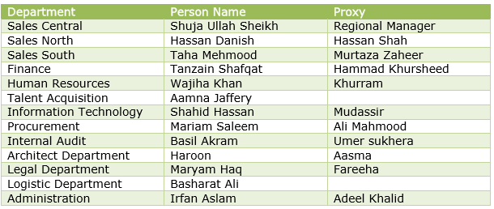
PROCESS FLOW
- Management Decision: Management will give go ahead for a new project to be initiated.
- Final Rental Agreement: Acquisition of building, shortlisting of relevant areas, final rental negotiations agreed by “Rental Negotiation Committee”. Scope and objective of the committee is mentioned below.
- Requirement Gathering: All the initial requirements shall be gathered by Admin Department regarding build out details, head counts, special requirements (if any) from various departments specifically Sales.
- Follow-Up of Build Out SOP: Build out SOP as defined below in Build out Process Flow shall be followed and complied upon as per defined timelines.
- Timelines of the Project: Timelines of the project shall be defined at early stage for timely execution and deliverables of the project. And same shall be shared with CFC
- Cross Functional Committee (CFC): Cross functional Committee along with all members shall be called upon and details and scope of the project will be presented. A sheet of predefined task at departmental level will be shared as defined in Checklist of Roles and Responsibilities and any additional requirements or feedback shall be provided by the stakeholders.
- Departmental Work in Process: Each department shall start working on their respective areas as per deadlines defined in the weekly scheduled meetings.
- Frequency of the Meeting: Progress of the work shall be shared in CFC scheduled (Friday) meeting each week as per defined date and should be updated in the predefined checklist.

LESSON LEARNT REPORT
At the end of each project outcomes of the project will be gathered in a way to identify loopholes and shortcoming’s if any for future course of action and improvements accordingly. Budgeted vs actual variance analysis with regards to cost and timelines shall be presented to the management.

ROLES & RESPONSIBILITIES
- Sales
Sales will be responsible for sharing their requirements with regards to staff head count, meeting rooms, prayer rooms, cafeteria, managerial offices and etc.
- Administration
- Detailed requirement gathering from relevant departments.
- Creation of “WhatsApp group” for timely coordination of any updates/invites regarding meetings.
- Timely creation of work orders as per given timelines.
- Ensure qualitative aspects during the execution and its timely reporting in case of anomalies.
- Real time monitoring of BOQ with actual.
- Preparation of day wise schedule with the vendor and ensuring its compliance on regular intervals.
- Requirements to be shared with procurement regarding Furniture & fixtures, electrical equipment, Air conditioners and generators.
- Finalizing the measurements as per actual with the defined BOQ after completion of the project
- Architect Department
To ensure accurate BOQ preparation, design and layouts preparation of the location in the given timelines.
- Procurement
To ensure timely procurement and tagging of goods and services, RFQ generation, comparative statement analysis and relevant vendor selection as per approval of CPC committee.
- Information Technology
To ensure that all the networking, internet connectivity and any required dedicated technical resource is allocated at the project as per the defined project deadlines.
- Legal Team
To ensure timely creation of contract for timely proceeding of the process.
- Finance
To ensure timely disbursement of funds for capex, payments to vendors against services and timely disbursements as per scheduled installment plans.
- HR Operations
- Ensuring timely installation of attendance machines and relevant initial office setup requirements at relevant locations.
- To ensure timely recruitment of relevant required staff at departmental level and trainings accordingly.
- Marketing
Branding related all requirements should be provided by marketing at initial stage.
- Internal Audit
To ensure accurate payments through pre-audit and to ensure compliance of overall build out activity.

Rental Negotiation Committee
Mandate
Any transaction including build outs
Composition of Committee Members
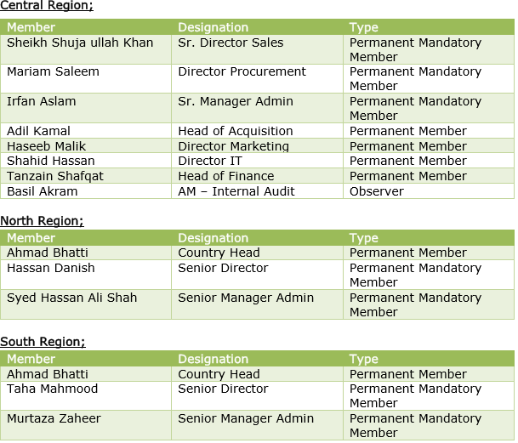
Meeting Frequency
RNC shall convene as and when the need arises. HOD Sales or Admin shall be responsible to arrange the meeting of the RNC.
Quorum Compliance
At least 3 permanent committee members for central region must be present in addition to the Head of the Committee. Alternatively, all cases are to be presented by head/nominated proxy of the head department, failing which, case shall be deferred to next RNC

Terms of Reference of RNC Committee
The terms of reference of RNC Committee shall be as follows:
- Develop an overall governance structure for the Rental agreements and recommending; standard operating procedures and key performance indicators to ensure fair, competitive and transparent agreements.
- Evaluate and review the need assessment of the desired location.
- Selection of the landlord based on the quote analysis / comparative statement, environmental impact and technical evaluation including assessment of similar deployments, product experience and market reputation.
- Ensure that agreed commercial terms are in line with the general market practices.
- Roles and responsibilities at the landlord side are clearly discussed, agreed and made part of the agreement.
- Take any decision with respect to rental agreements as directed or delegated by the Office of CEO.
Decision Mechanism
Once the quorum finalizes any decision, it is the responsibility of HOD Sales or Admin to share detailed email against the decision made to the committee members keeping office of CEO in loop. This approval email shall be attached with the standard documentation trail required to initiate any payment request through Finance

Checklist of Roles & Responsibilities
